Lecture No. 22 PARASITOLOGY DR.Raad H.H.
Protozology
"flagellates"
General characteristics of flagellates :
- One or more flagella--some may have pseudopodia
- Most of the time, the active (feeding) stage is termed a "trophozoite."
- Many, but not all, form resistant cysts which are the way most are transmitted between hosts
- Longitudinal binary fission of the trophozoite is the main mode of reproduction (asexual) .
- Costa (striated rod of protein, runs from one kinetosome along margin of organism just under undulating membrane when present; support) .
- Axostyle (longitudinal rod of microtubules running length of some flagellates ).
- Parabasal body (large, modified Golgi apparatus {=dictyosome in some genera}).
- Parabasal filament (periodic fibril in some, runs from parabasal body in kinetosome in some) .
- Nucleus vesicular 1 or 2
- Nutrition is autotrophic (making its own food by photosynthesis, as a green plant does, or by chemosynthesis, as any of certain bacteria do ) or heterotrophic (An organism that cannot synthesize its own food and is dependent on complex organic substances for nutrition ). Those that are heterotrophic may be holozoic (Obtaining nourishment by the ingestion of organic material, as animals do. Used by certain protozoans ) or saprozoic (Obtaining nourishment by absorption of dissolved organic and inorganic materials, as in protozoans and some fungi ).
- Extracellular e.g. Trypanosome or intracellular e.g. Leishmania.
- Infect either blood (trypanosome ) or intestinal (Giardia ) or genital systems ( Trichomonas ).

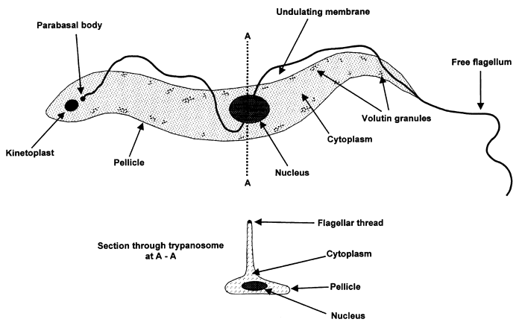

- Transmition modes
- direct
- ingestion e.g. Trichomonas gallinae
- sexual e.g. Trichomonas faetus
- indirect by arthropod intermediate host
- biological ( parasite change in shape and No. ) Trypanosoma brucei in Glossina fly.
- Mechanical e.g. Trypanosoma evansi in Tabanus fly.
Pylum Kinetoplastida
Contain 1 kinetoplast , had 1 flagellum with undulating membrane, all parasitic (e.g. Trypanosomes ) ; or 2 flagella without undulating membrane , free-living or parasitic members (e.g. Cryptobia ) in Fishes .
Kinetoplast:
An oval or rod-shaped body seen in hemoflagellates. It stains with nuclear dyes and contains DNA. It is regarded as a modified part of the mitochondrium.

Pleomorphic: When a number of morphological types occur in one life cycle.

Monomorphic: When only a single morphological type occurs in one life cycle.

Axoneme: A delicate filament extending from the region of the kinetoplast to the cell membrane. It represents the cytoplasmic part of the flagellum.

Order Trypanosomatida
Family: Trypanosomatidae
- TRYPANOSOMES AND LEISHMANIA
- Most heteroxenous (more than 1 host) , utilizing vertebrate and non-vertebrate hosts ; monoxenous as in T. equiperdum
- Single flagellum situated anteriorly originates from basal body near Kinetoplast and is surrounded by a sheath and undulating membrane (Thin protoplasmic sheet ); it extends to exterior of the parasite fusi form by free part of flagellum.

Metacyclic form : Infective forms which develop in the vector insect stage of Leishmania species and Trypanosoma .

Procyclic forms : either dividing form of Trypanosoma brucei found in the tsetse fly midgut, or non-infective promastigote stage of Leishmania species, found in the sand fly vector.
- All are hemoflagellates
- All are pleomorphic (varation in body shapes) at various life-cycle stages ; have 4 FORMS ; each species under go at least 2 forms in it’s life cycle ;
Trypanosomatidae pleomorphic forms are :
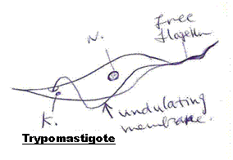
  - Trypomastigote (kinetoplast posterior to nucelus; undulating membrane runs length of organism).

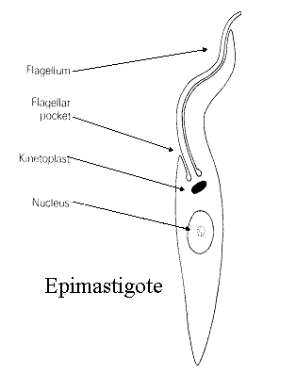
  - Epimastigote (kinetoplast anterior to nucleus; undulating membrane running a portion of the body) .

Epimastigote is found in the intestinal tract of the insect host.
This form is found in Trypanosoma brucei and T. cruzi.
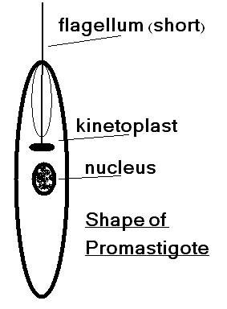
  - Promastigote (kinetoplast anterior to nucleus; no undulating membrane) .

Promastigote One of the morphological stages in the development of Leishmania species. Promastigote is an extracellular motile form that divides by longitudinal binary fisson in the sand fly. They are characterized by a free anterior flagellum and the kinetoplast at the anterior end of the body. They can be either procyclic or metacyclic form.
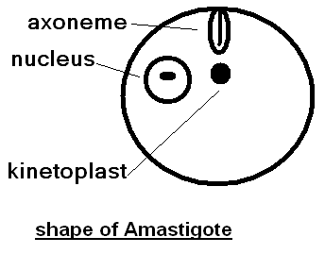
  - Amastigote (kinetoplast anterior to nucelus; no free flagellum; usually spheroid or subspheroid).

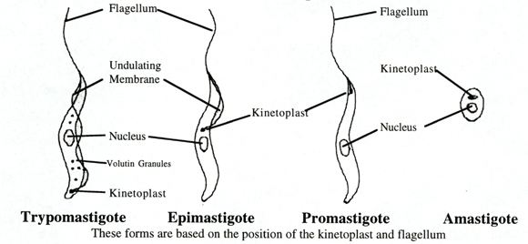

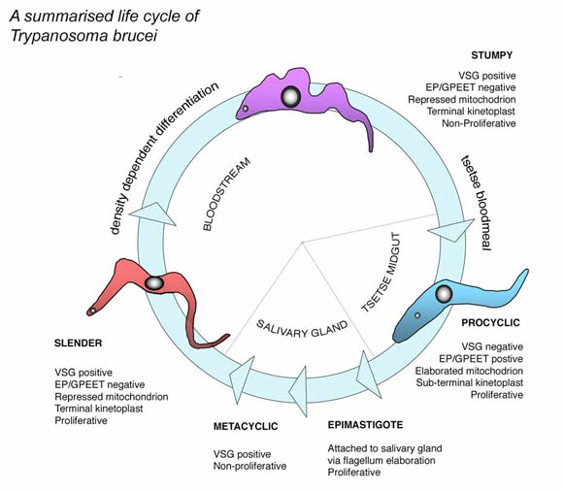

Genus Trypanosoma
- Most members heteroxenous, or at least are transmitted paratenically by vector .
- Single flagellum , fusi form shape.
- Usually, trypomastigotes ; in vertebrate and epimastigotes in invertebrate.
- Often divided into 2 traditional groups (although evolutionarily some are quite distinct) .
  - Salivaria (or anterior station)
    - most species develop in anterior portion of the insect gut .
    - most transmitted by bite of an insect.
    - typical life-cycle of Trypanosoma brucei in ruminants :
      - Slender, medium-sized, and stumpy trypomastigotes in blood stream of vertebrate host
      - Ingested by tsetse (Glossina spp.)
      - Only stumpy forms survive; migrate to posterior portion of mid-gut
      - Divide by longitudinal binary fission for about 10 days; in process transform into slender trypomastigotes
      - Migrate to foregut and remain for 12-20 days
      - Migrate to anteriorly; get into salivary glands
      - Transform into epimastigotes; divide several times by longitudinal binary fission
      - Transform into metacyclic trypomastigotes (small and stumpy trypomastigote without free flagellum)
      - During feeding, metacyclic trypomastigotes injected into new host
      - Once inside vertebrate, metacyclic trypomastigotes divide and the parasites gradually become slender and elongate
      - Eventually, some trypomastigotes also become short and stumpy .
    - Antigenic variation :
      - Some species (i.e. T. brucei, T. gambiense, T. rhodesiense, T. vivax) are capable of changing surface glycoproteins
      - Each trypanosome has 20% of its dry weight composed of a single variable surface glycoprotein (VSG) variant surface glycoprotein , is a coat located at the trypanosome surface protein responsible of Antigenic variation phenomenon in African trypanosomiasis
    - Pathogenesis :
      - In species undergoing antigenic variation, the glycoproteins are continually shed and are toxic ,leading to fever and ↓RBC lead to Anemia and toxins lead to ↑blood vessels permeiability diffusion causig Edema; the parasite cause highly consumption of glycoprotein leading to Coma; Some species cause acute disease, which include anaphylactic reactions, physiological imbalance, generalized pain, swelling of lymph nodes, weakness, cramps, shock, and death within 6 months after infection. Others can become chronic, with trypomastigotes invading CNS. This can involve apathy, muscle tremors, long term neurological problems that involve paralysis and convulsions, coma, and eventually death. Sleeping sickness in animals is termed "Nagana".
      - Dourine is caused by T. equiperdum and progresses from a severe venereal disease into gradual paralysis and death in equids .

representative species
- Trypanosoma brucei (widely distributed in tropical Africa; vertebrate host ruminants, although equids , swine, etc can also be infected; vector tsetse flies; disease in animals termed "Nagana" characterized by oedema , anemia, hind legs paralysis ,muscular atrophy )
- Trypanosoma congolense (South Africa; infects large mammals; vectors tsetse flies , cause disease in animals termed "Nagana")
- Trypanosoma equinum (South America; horses only; no kinetoplast; transmitted mechanically by biting flies; thought to be derived from T. evansi)
- Trypanosoma equiperdum (Africa, Asia, portions of Europe, Mexico; transmitted directly during coitus; thought to have originated from T. brucei; equine fatal disease termed "Dourine ")
- Trypanosoma evansi (Northern Africa, Asia, Europe, Central and South America; in many species of large mammals; transmitted mechanically in mouthparts of dipterans and even vampire bats; highly pathogenic in horses, dogs, and elephants; original host thought to be camels; disease termed "Surra" or murrina or Eldabab in Sudancharacterized by oedema , anemia, hind legs paralysis ,muscular atrophy ,conjecivitis , abortion pneumonia , CNS sings ,pica ,death )
- Trypanosoma gambiense (Central and West central Africa; humans the main vertebrate host; vectors tsetse flies, Slow developing disease parasite , The disease called African Trypanosomiasis (Sleeping Sickness).
- Trypanosoma rhodesiense (Central and East central Africa; humans and native game animals suitable vertebrate hosts; vectors tsetse flies , Rapid progressive disease parasite )
- Trypanosoma vivax (Tropical Africa; introduced into South America; large mammals as hosts; vectors tsetse flies in Africa and mechanically by tabanids in the Western hemisphere , cause disease in animals termed "Nagana" )

  - Stercoraria
    - most develop in hindgut of insect
    - most transmitted in feces of insect
    - life-cycle of "Trypanosoma cruzi "
      - Trypomastigotes in blood
      - ingested by reduviids
      - migrate to posterior portion of midgut
      - divide by longitudinal binary fission as epimastigotes
      - 8-10 days later, migrate to rectum and transform into metacyclic trypomastigotes
      - two routes of infection
        - during feeding, bug defecates to clear gut and parasites deposited on skin near bite; rubbed into wound by victim
        - infected bug ingested by vertebrate
      - binds to fibronectin receptors of phagocytic cells; engulfed, especially those of reticulo-endothelial system initially
      - transform into amastigotes
      - divide by binary fission, eventually destroying cell
      - cycle continues and disseminates throughout body as new cells engulf amastigotes
      - occasionally transformation in to trypomastigotes, which circulate in blood
      - Chaga's disease has been found in Children in Chilean and Peruvian mummies dated to 9,000 BP .

representative species
- Trypanosoma cervi (may be cosmopolitan; in cervids; vectors tabanids; non-pathogenic)
- Trypanosoma cruzi (North, Central and South America; in many medium-size mammals and humans; vectors reduviids; can be fatal)
- Trypanosoma kansasensis (North America east of the rockies; in woodrats; vectors fleas; non-pathogenic)
- Trypanosoma lewisi (Cosmopolitan; in old world rats; vectors are fleas where the parasite is ingested along with the flea or its feces; non-pathogenic)
- Trypanosoma rangeli (Northen South America and Central America; in primates, xenarthra, and opossums; vectors reduviids; kinetoplast tiny; non-pathogenic) it is called also Lewisi group.
- Trypanosoma musculi (Cosmopolitan; in old world mice; vectors are fleas; non-pathogenic)
- Trypanosoma peromysci (North America; in Peromyscus spp.; vectors fleas; non-pathogenic)
- Trypanosoma theileri (Cosmopolitan; in cattle; vectors tabanids; non-pathogenic) it is called also Megatrypanum
Diagnosis:
- Clinical signs and symptoms
- Examination of the Blood and lymph smears by light microscopy i.e. examination of fresh or stained blood films.
- Immunodiagnostic techniques: complement fixation test CFT; indirect haemagglutination (IHA) test; The indirect fluorescent antibody test (IFAT) ; enzyme-linked immunosorbent assays (ELISA).
- Xenodiagnosis: A method of diagnosis in which a vector is fed on a suspected case and later examined for presence of the parasite.
- Chemical test ( non specific test) Formal gel test or Mercuric chloride turbidity .
- Mouse inoculation.
Treatment :
- Human Intravenous or intramuscular Pentamidine or Suramin are given for the hemolymphatic stage.
- Diminazene aceturate “Berenil”
Homidium bromide "Ethidium"
- Isometamidium "Samorin"" Trypamidium"
- Quinapyramine sulphate "Trypacide"
Control :
- The use of insecticide-treated cattle to control tsetse is an increasingly important means of controlling trypanosomiasis.
- Treatment
- Control animal reservoir
- Breeding of natural resistant cattle breeds
- Healthy equine coitus & exam. of stallion from dourine periodically.

Genus Leishmania
- Development in midgut and foregut of sandfly (i.e. Phlebotomus spp. and Sergentomyia spp. in the Old World; Lutzomyia spp., Brumptomyia spp., and Warileya spp. in the New World) .
- Both Old World and New World species.
- Heteroxenous
- Amastigote (Intracellular form) , (Leishman - Donovan body) in macrophages of vertebrate; Promastigotes (Extracelluar ) form , in invertebrate .
- Vectors female sandflies
- Typical life-cycle
  - amastigotes in tissues and fluids in dermis
  - sandfly sucks blood and ingests amastigotes
  - within midgut, amastigotes transform into promastigotes and divide by longitudinal binary fission
  - move up to esophagus and amass
  - when sandfly takes another blood meal, clogged esophagus is cleared by arthropod pumping action effectively injecting some parasites into wound
  - promastigotes ingested by macrophages and other phagocytic cells
  - transform into asmastigotes
  - binary fission, destroying cell in process
- pathogenesis
  - each species, or complex of species, has a different pathology. Some remain in dermis (cutaneous ), some become muco-cutaneous, whereas others become visceral.
  - erosion of tissue due to cellular destruction, not only by parasite but especially by host immune response .
- Classification of the genus Leishmania :
representative species in mammals (about 25 named species to date)
      - Leishmania donovani complex (New and Old World; visceral leishmaniasis)
        - Leishmania archibaldi (Portions of Africa; in humans, some rodents, some carnivores; visceral leishmaniasis)
        - Leishmania chagasi (South and Central America, perhaps entering canids in North America; in canids and humans, perhaps some rats and opossum; causes severe viscercal leishmaniasis)
        - Leishmania donovani (Portions of Africa, India, east Asia; in humans, perhaps canids, primates, equids, some rodents; visceral leishmaniasis)
        - Leishmania infantum (India, Mediterranean region, Asia, middle east, portions of Europe; in humans, dogs, and perhaps rodents; visceral leishmaniasis)
      - Leishmania hertigi complex (all New World)
        - Leishmania deanei (Brazil; tree-porcupines; cutaneous)
        - Leishmania hertigi (Panama and Costa Rica; tree porcupines; cutaneous)
      - Leishmania mexicana complex (all New World)
        - Leishmania amazonensis (South America; rodents, marsupials, fox; single sore cutaneous leishmaniasis)
        - Leishmania aristidesi (Panama; rodents and marsupials; cutaneous)
        - Leishmania enriettii (Brazil; guinea pigs only; tumor-like lesions on ears)
        - Leishmania forattinii (Brazil; in opossum and rodents; skin lesions and have also been isolated from the liver)
        - Leishmania garnhami (Andes; humans and opossum; cutaneous)
        - Leishmania mexicana (North and Central America, perhaps South America; rodents and humans; deep cutaneous leishmaniasis with severe lesions on ear being common)
        - Leishmania pifanoi (Venezuela; humans known hosts and perhaps rodents; deep cutaneous leishmaniasis)
        - Leishmania venezuelensis (Venezuela; humans, equids, felids; single and multiple cutaneous ulcers, sometimes disseminating)
      - Leishmania tropica complex (all Old World)
        - Leishmania aethiopica (Ethiopia and Kenya; in hyrax, giant rat, humans; highland cutaneous leishmaniasis)
        - Leishmania gerbili (South Mongolia; gerbils)
        - Leishmania major (Portions of Africa, middle east, Asia, India, southern Russia; humans, rodents, mustelids, hedgehogs, rabbits; wet cutaneous lesions, "Baghdad boil" )
        - Leishmania tropica (Europe, North Africa, middle East, South Russia, India; in canids and humans, perhaps some rodents; dry cutaneous lesions , "Baghdad boil") .
Diagnosis:
1. Microscopy
Leishmaniasis is diagnosed in the haematology laboratory by direct visualization of the amastigotes (Leishman-Donovan bodies) . Buffy-coat preparations of peripheral blood or Biopsy aspirates from marrow, spleen, lymph nodes or skin lesions should be spread on a slide to make a thin smear, and stained with Leishman's or Giemsa's stain (pH 7.2) for 20 minutes. Amastigotes are seen with monocytes or, less commonly in neutrophil in peripheral blood and in macrophages in aspirates. They are small, round bodies 2-4μm in diameter with indistinct cytoplasm, a nucleus and a small rod-shaped kinetoplast. Occasionally amastigotes may be seen lying free between cells
2. Culture
The aspirates can be cultured in Novy-Nicolle-MacNeal (NNN) or Schneider's Drosophila medium. In culture the amastigote stage converts to the promastigote stage. However, this is not a rapid technique, as the parasites may take anything from 10 - 21 days to grow.
3. Serodiagnosis
VL produces large amounts of specific IgG which can be used for diagnosis. Currently the most used sero diagnostic tests are Indirect-immuno Fluorescent Antibody Test (IFAT), Enzyme Linked Immunosorbent Assay (ELISA) and Direct Agglutination Test (DAT).
4. Routine sand fly exam. by dissection

Control:
- Suppress the reservoir: dogs, rats, gerbils, other small mammals and rodents

- Suppress the vector: Sand fly
  - Critical to preventing disease in stationary troop populations

- Prevent sand fly bites:
- Personal Protective Measures
  - Most important at night
  - Sleeves of cloths down
  - Insect repellent w/ DEET
  - Permethrin treated uniforms
  - Permethrin treated bed nets

